**DAY 3**

**(Deployment of Kubernetes)**

**CLI**

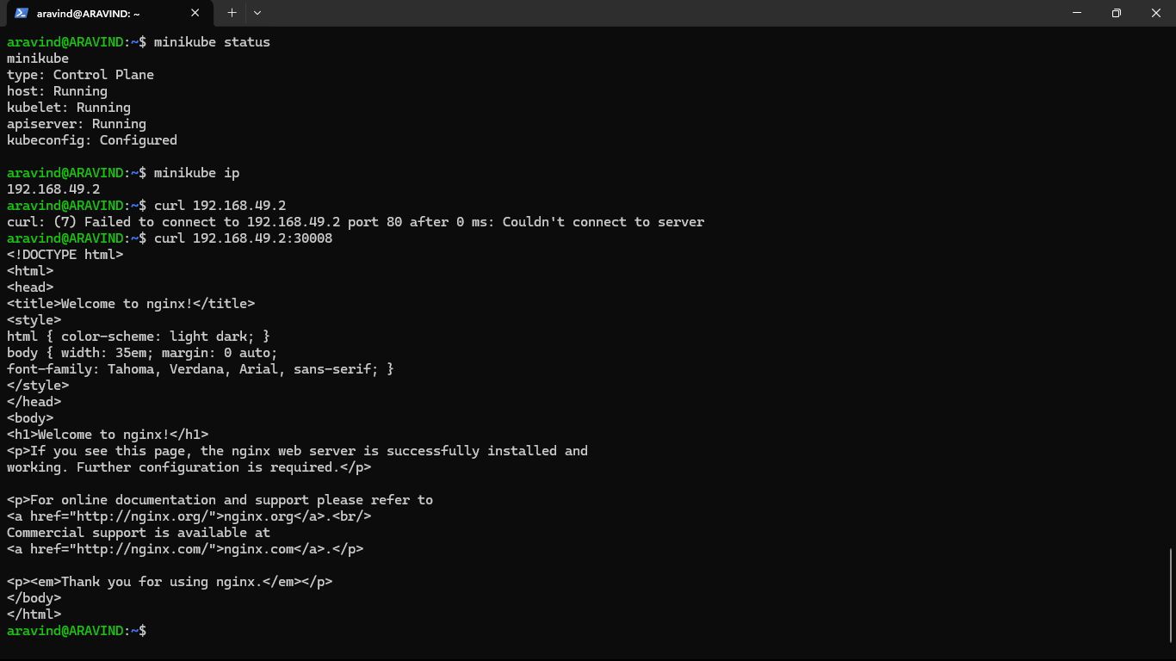

**OUTPUT**

